**Lab Assignment – Enterprise IAAA Part 2 (Authorization)**

**Guideline:**

* You are **ALLOWED** to reference the course materials and online content to complete the lab.
* It is your responsibility to **BACKUP** your virtual machine(s) to your external drive.
* **FOLLOW** the instructions outlined in this document to avoid losing marks.

**Deliverables**

* Provide answers for questions outlined in the last page of this document. The answers will be in a form of screenshots that shows the configuration. Make sure the screenshots are visible and clear before uploading and submitting to Brightspace.

**Active Directory Domain Administration**

* + Login to the server using the domain administrator account and open Active Directory Users and Computers and create the following objects
    - Under Account Payable OU, create the following objects

|  |  |  |  |
| --- | --- | --- | --- |
| Object Type | Scope | Type | Group Name |
| Group | Global | Security | AP Group |

Add the following users as members of AP Group

|  |  |  |  |
| --- | --- | --- | --- |
| Object Type | First name | Last name | Full name |
| User | Henry | Ford | Henry Ford |
| User | Enzo | Ferrari | Enzo Ferrari |

* + - Under Account Receivable OU, create the following objects

|  |  |  |  |
| --- | --- | --- | --- |
| Object Type | Scope | Type | Group Name |
| Group | Global | Security | AR Group |

Add the following users as member of AR Group

|  |  |  |  |
| --- | --- | --- | --- |
| Object Type | First name | Last name | Full name |
| User | Ferdinand | Porsche | Ferdinand Porsche |
| User | Louis | Chevrolet | Louis Chevrolet |
| User | Karl | Probst | Karl Probst |

**Storage Requirements**

* Create an additional disk drive on your AD domain controller
  + Virtual disk type > SCSI
  + Assign **60GB** size
  + Continue the setup using the default options
  + Bring the disk up to online the initialize it using the default options
  + Create a simple volume using a drive letter of your choice and make sure it is ready for use

**Permissions Requirements**

* + Create a folder under the new volume named Finance
  + Create two sub folders under Finance named Accounts Payable & Accounts Receivable
  + Ensure that modify access to Accounts Payable folder is granted to AP Group only
  + Ensure that read access to Accounts Receivable folder is granted to AR Group only
  + Ensure that Domain Administrators group have full control over Finance folder and all sub folders.

**Network Access**

**(Client win10) Domain: Arr.local**

Login to the client O/S using **Henry Ford’s accoun**t and map the Finance Folder the validate his access to Accounts Payable folder

**Arr\Henry.Ford**

BlueSky!2025Road

New pw of HENRY: **qwerty01A!HENR**

Cmd command in win server2019:

>> hostname -🡪 Arr01 (this is the computer name)

>> whoami 🡪 arr\administrator (arr is the domain controller name)

* + Login to the client O/S using Louis Chevrolet’s account and map the Finance Folder the validate his access to Accounts Receivable folder

**Arr\** **Louis.** **Chevrolet**

BlueSky!2025Road

New pw of Louis: **qwerty01A!LOUI**

**Linux Virtual Machine and O/S Requirements 🡪 START HERE!!!, CANT ping Arr.local**

* Create a new virtual machine that contains the following specifications
  + The guest operating system of the virtual machine should be **Ubuntu Server**
  + Assign **4GB RAM** to the virtual machine **BEFORE** installing the operating system.
  + Start your virtual machine and install the operating system.
  + Set the computer name to Your last name followed by 01 appended to it. For example, if your last name is Wayne then the computer name should be Wayne01
  + Continue the setup using the default options

**Integrated Network Access**

* + Set a static IP of your choice on the Linux Server
  + Join the Linux Server to the domain
  + Mount the new volume and access the Finance folder

**Questions**

**Note: Provide screenshots for below requirements as evidence of your configuration. Editing/cropping screenshots will not be accepted**

1. Login to your AD domain controller and right-click on Accounts Payable Folder > Security tab. Highlight the AP Group then take a screenshot and save it as jpeg file.

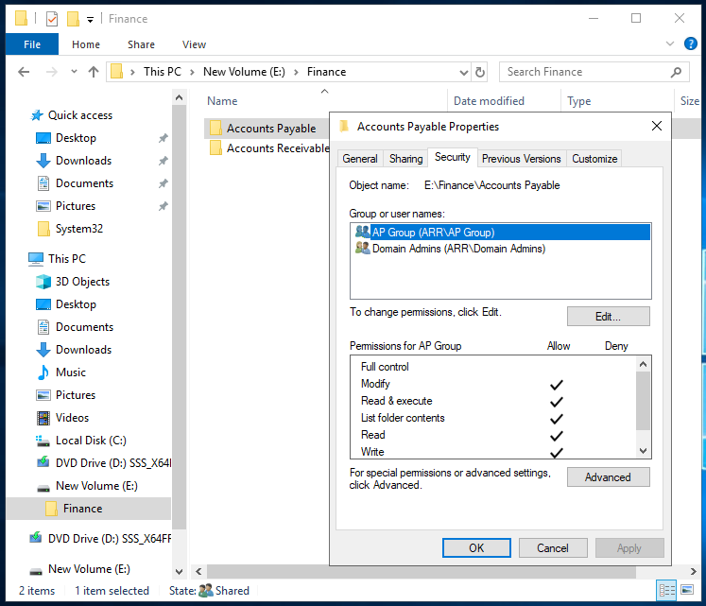

1. Login to your AD domain controller and right-click on Accounts Receivable Folder > Security tab. Highlight the AR Group then take a screenshot and save it as jpeg file.

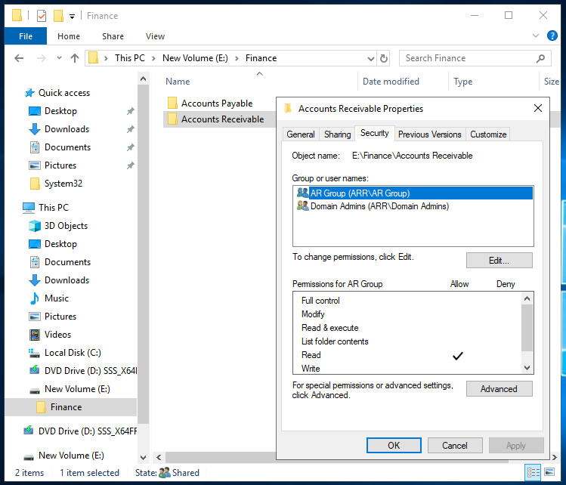

1. Login to your AD domain controller and open AD Users and Computer tool. Find and double-click on the AP Group > Members tab then take a screenshot and save it as jpeg file.

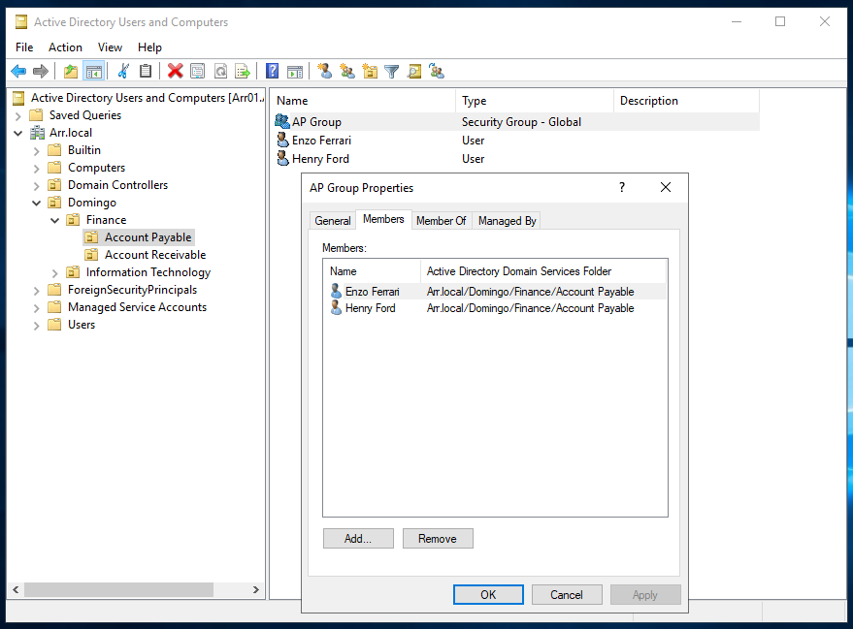

1. Login to your AD domain controller and open AD Users and Computer tool. Find and double-click on the AR Group > Members tab then take a screenshot and save it as jpeg file.

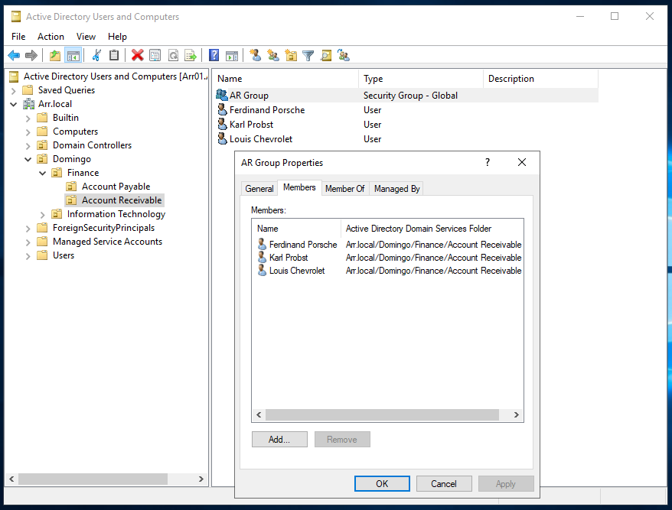

1. Login to the Linux Server and browse the mounted volume using the la -al command. The output should display the Finance folder. Take a screenshot and save it as a jpeg file.

**Marking Guide**

Each screenshot should show the configuration you have made. The grades are divided equally among all requirements. Each answer is worth 2% out of 10%. No partial marks on individual requirement.

|  |  |  |  |
| --- | --- | --- | --- |
| Deliverables | (Yes / No) | Feedback | Marks (2% Each) |
| Accounts Payable Folder > Security tab |  |  |  |
| Accounts Receivable Folder > Security tab |  |  |  |
| Members of AP Group in AD |  |  |  |
| Members of AR Group in AD |  |  |  |
| Mount Access to the new volume |  |  |  |

**Submission**

You are required to submit the following in a single zip folder

1. A single screenshot for requirement 1, 2, 3, 4, and 5. (Total of 5 screenshots)
2. All above submissions must be saved in a folder then zipped and uploaded to Lab 1 – Part 2 (Authorization) on Brightspace.